**DESIGN AND SIMULATION OF AlGaN/GaN HIGH ELECTRON MOBILITY TRANSISTORS (HEMTS) USING SILVACO TCAD**

By

**ATUL KUMAR SINGH (0000001538/A/2021)**

**ROHIT KUMAR VERMA (0000001578/A/2021)**

**DEEPAK BAIDYA (0000001549/A/2021)**



**National Institute of Technology**

**Arunachal Pradesh**

(Established by Ministry of Education, Govt. of India)

Jote, District: Papum Pare, Arunachal Pradesh 791113

May, 2025

**DESIGN AND SIMULATION OF AlGaN/GaN HIGH ELECTRON MOBILITY TRANSISTORS (HEMTS) USING SILVACO TCAD**

**(EC-499)**

**Thesis**

Submitted in partial fulfillment of the

requirements for the award of degree of

**Bachelor of Technology**

By

**ATUL KUMAR SINGH (0000001538/A/2021)**

**ROHIT KUMAR VERMA (0000001578/A/2021)**

**DEEPAK BAIDYA (0000001549/A/2021)**

Under the supervision of:

**Dr. Subhadeep Mukhopadhyay**

Assistant Professor

Department of Electronics & Communication Engineering



Department of Electronics & Communication Engineering

**National Institute of Technology**

**Arunachal Pradesh**

(Established by Ministry of Education, Govt. of India)

Jote, District: Papum Pare, Arunachal Pradesh 791113

May, 2025

© NATIONAL INSTITUTE OF TECHNOLOGY, ARUNACHAL PRADESH

JOTE 2025

ALL RIGHTS RESERVED



**CERTIFICATE OF APPROVAL**

The dissertation entitled “**DESIGN AND SIMULATION OF AlGaN/GaN HIGH ELECTRON MOBILITY TRANSISTOR USING SILVACO TCAD”** submitted by **Atul Kumar Singh (0000001538/A/2021) , Rohit Kumar Verma (0000001578/A/2021), Deepak Baidya (0000001549/A/2021)** is presented in a satisfactory manner to warrant its acceptance as a prerequisite for the degree of Bachelor of Technology in Electronics & Communication Engineering of the National Institute of Technology, Arunachal Pradesh. It is understood that by this approval the undersigned do not necessarily endorse or approve any statement made, opinion expressed or conclusion drawn therein, but only for the purpose for which it has been submitted.

**BOARD OF EXAMINERS:**

1. External Examiner

2. Internal Examiner

**CERTIFICATE FROM SUPERVISOR**

This is to certify that the dissertation entitled “**DESIGN AND SIMULATION OF AlGaN/GaN HIGH ELECTRON MOBILITY TRANSISTOR USING SILVACO TCAD”** submitted by **Atul Kumar Singh (0000001538/A/2021), Rohit Kumar Verma (0000001578/A/2021), Deepak Baidya (0000001549/A/2021)** to the Department of Electronics & Communication Engineering of the National Institute of Technology, Arunachal Pradesh, as a partial fulfillment of their B. Tech Degree in Electronics & Communication Engineering of the Institute is absolutely based upon their own work, carried out during the period from January – May, 2025 under my supervision. Neither this dissertation nor any part of it has been submitted for the award of any other degree of this Institute or any other Institute/University.

**Dr. Subhadeep Mukhopadhyay**

**Assistant Professor**

**Department of Electronics & Communication Engineering**

**NIT Arunachal Pradesh**

**Date:**

**Place: Jote, NIT Arunachal Pradesh**

**ACKNOWLEDGEMENT**

I take this opportunity to express my deepest gratitude to **Dr. Subhadeep Mukhopadhyay**, Assistant Professor, Department of Electronics and Communication Engineering, for his invaluable guidance, encouragement, and support throughout the course of this project. His insightful feedback, expert knowledge, and continuous motivation were instrumental in the successful completion of this thesis titled *“*DESIGN AND SIMULATION OF AlGaN/GaN HIGH ELECTRON MOBILITY TRANSISTORS (HEMTs) USING SILVACO TCAD.” His mentorship has been a source of inspiration and learning at every stage of this work.

I would also like to extend my sincere thanks to the **Department of Electronics and Communication Engineering, National Institute of Technology, Arunachal Pradesh**, for providing the necessary academic infrastructure, support, and a conducive environment to carry out this research.

Furthermore, I am grateful to all faculty members and staff of the department for their direct or indirect support throughout my undergraduate journey.

Last but not least, I extend my heartfelt appreciation to my family for their unconditional love, patience, and unwavering support throughout this endeavour. Their belief in me has been a constant source of strength and motivation.

Atul Kumar Singh Rohit Kumar Verma Deepak Baidya

(EC21B012) (EC21B050) (EC21B023)

**ABSTRACT**

The growing demand for high-performance, high-frequency electronic components has made wide bandgap materials, especially GaN-based HEMTs (High Electron Mobility Transistors), a topic of interest. AlGaN/GaN HEMTs are particularly appealing because of their excellent electron mobility, high breakdown voltage, and exceptional thermal stability. This thesis explores the design and simulation of AlGaN/GaN HEMT structures utilizing Silvaco TCAD tools, focusing on how changes in essential design parameters influence the device's I-V characteristics.

The thesis opens with a discussion on the operating principles of HEMTs, detailing the formation of the two-dimensional electron gas (2DEG) at the interface of AlGaN/GaN. It also examines the polarization effects that significantly enhance carrier mobility and boost device performance. Following this, an overview of Silvaco TCAD is presented, illustrating how this simulation platform effectively models semiconductor devices with high precision.

The main research concentrates on three key factors: the thickness of the AlGaN barrier layer, the aluminium mole fraction, and the doping concentration in the AlGaN layer. Initially, the thickness of the AlGaN layer is modified while keeping the other two factors unchanged. Simulation outcomes indicate that increasing the layer's thickness enhances the polarization effect at the interface, resulting in a higher 2DEG density and improved drain current. However, if the thickness exceeds a certain limit, excessive strain may compromise the material's integrity.

The second phase of the investigation assesses how varying the aluminium mole fraction affects the device. A greater mole fraction further amplifies polarization, boosting electron density and enhancing output current. However, excessively high mole fractions may lead to lattice mismatch, which increases defect density and decreases reliability. Finally, the doping concentration in the AlGaN layer is varied while maintaining constant thickness and mole fraction. Higher doping levels result in improved carrier injection and increased current output, although they might also contribute to elevated leakage currents and decreased control over the threshold voltage.

The I-V characteristics derived from the simulations affirm the vital influence of these parameters on device functionality. This research emphasizes the necessity of finding a balance among these factors to achieve optimal performance, particularly for high-frequency and high-power applications.

In summary, this study emphasizes that careful adjustment of the AlGaN layer parameters—thickness, composition, and doping—can greatly improve the performance of AlGaN/GaN HEMTs. The conclusions provide valuable insights for device engineers and researchers involved in the development of next-generation GaN-based semiconductor technologies.

# LIST OF CONTENTS

CERTIFICATE OF APPROVAL i

CERTIFICATE FROM SUPERVISOR ii

ACKNOWLEDGEMENT iii

ABSTRACT iv

LIST OF CONTENTS v

LIST OF FIGURES vii

ACRONYMS viii

**CHAPTER-1**

**INTRODUCTION**

* 1. Objective …1

1.2 Scope of Implementation …2

**CHAPTER-2**

**LITERATURE REVIEW**

2.1 Additional Significant Contributions …5

2.2 Outcome of the Literature Review …5

**CHAPTER-3**

**HIGH ELECTRON MOBILITY TRANSISTOR (HEMT)**

3.1 HEMT Fundamentals …6

3.2 Structure of HEMT …7

3.3 Operation of AIGaN/GaN HEMT …9

3.3.1 Off State Operation

3.3.2 Linear Region

3.3.3 Saturation Region

3.4 Key Parameters and Equations of AIGaN/GaN HEMT …10

3.4.1 Two-Dimensional Electron Gas (2DEG) Sheet Density

3.4.2 Threshold Voltage

3.4.3 Drain Current in Linear Region

3.4.4 Drain Current in Saturation Region

3.4.5 Transconductance

3.4.6 Output Conductance

3.5 Energy-Band And 2DEG Formation in AlGaN/GaN HEMTS …12

**CHAPTER-4**

**DEVICE MODELING OF AlGaN/GaN HEMTs**

4.1 Introduction to Silvaco …15

4.2 Simulation Workflow in Atlas …16

4.2.1 Structure Definition

4.2.2 Material and Model Configuration

4.2.3 Numerical Method Selection

4.2.4 Simulation Execution

4.2.5 Data Extraction and Visualization

4.3 Design and Simulation of AlgaN/GaN HEMT Structure Using Silvaco Atlas …17

4.4 Variation of HEMT Output Characteristics with Design Parameters …18

4.4.1 Effect of AlGaN Thickness on I-V Characteristics

4.4.1.1 Effect of Thickness on Output Characteristics (ID - VDS)

4.4.1.2 Effect of Thickness on Transfer Characteristic (ID – VGS)

4.4.2 Effect of Mole Fraction Variation On I-V Characteristics

4.4.2.1 Effect of Mole fraction on Output Characteristics (ID - VDS)

4.4.2.2 Effect of Mole fraction on Transfer Characteristic (ID – VGS))

4.4.3 Effect of Doping Concentration Variation On I-V Characteristics

4.4.3.1 Effect of Doping Concentration on Output Characteristics (ID - VDS) 4.4.3.2 Effect of Doping concentration on Transfer Characteristic (IDS – VGS)

**CHAPTER-5**

**CONCLUSION AND FUTURE WORK**

5.1 Conclusion …31

5.2 Future Work …32

REFERENCES …33

**LIST OF FIGURES**

|  |  |  |
| --- | --- | --- |
| **Figure** | **Title** | **Page** |
| Figure 3.1 | HEMT Structure | 7 |
| Figure 3.2 | Bandgap Diagram of AlGaN/GaN HEMT | 13 |
| Figure 4.1 | Silvaco Simulation Flowchart | 16 |
| Figure 4.2 | Schematic Representation of an AlGaN/GaN Double-Heterojunction HEMT Structure Featuring a 32 nm AlGaN Barrier and a Fixed Gate Length of 2000 nm | 18 |
| Figure 4.3 | Drain characteristics of AlGaN/GaN HEMT with AlGaN barrier thickness of 22 nm, Al mole fraction x=0.33, and doping concentration 1.5×10¹⁸ cm⁻³. | 20 |
| Figure 4.4 | Drain characteristics of AlGaN/GaN HEMT with AlGaN barrier thickness of 27 nm, Al mole fraction x=0.33, and doping concentration 1.5×10¹⁸ cm⁻³. | 20 |
| Figure 4.5 | Drain characteristics of AlGaN/GaN HEMT with AlGaN barrier thickness of 32 nm, Al mole fraction x=0.33, and doping concentration 1.5×10¹⁸ cm⁻³. | 21 |
| Figure 4.6 | Variation of Drain Current with Gate Voltage for Thickness 22 nm and Al Mole Fraction of 0.33, with Doping Concentration of 1.5×10¹⁸ cm⁻³. | 22 |
| Figure 4.7 | Variation of Drain Current with Gate Voltage for Thickness 27 nm and Al Mole Fraction of 0.33, with Doping Concentration of 1.5×10¹⁸ cm⁻³. | 22 |
| Figure 4.8 | Variation of Drain Current with Gate Voltage for Thickness 32 nm and Al Mole Fraction of 0.33, with Doping Concentration of 1.5×10¹⁸ cm⁻³. | 23 |
| Figure 4.9 | Drain characteristics of AlGaN/GaN HEMT with AlGaN barrier thickness of 32 nm, Al mole fraction x=0.28, and doping concentration 2.5×10¹⁸ cm⁻³. | 24 |
| Figure 4.10 | Drain characteristics of AlGaN/GaN HEMT with AlGaN barrier thickness of 32 nm, Al mole fraction x=0.33, and doping concentration 2.5×10¹⁸ cm⁻³. | 24 |
| Figure 4.11 | Variation of Drain Current with Gate Voltage for T = 32 nm and Al Mole Fraction of 0.28, with Doping Concentration of 2.5×10¹⁸ cm⁻³. | 25 |
| Figure 4.12 | Variation of Drain Current with Gate Voltage for T = 32 nm and Al Mole Fraction of 0.33, with Doping Concentration of 2.5×10¹⁸ cm⁻³. | 26 |
| Figure 4.13 | Drain characteristics of AlGaN/GaN HEMT with AlGaN barrier thickness of 27 nm, Al mole fraction x=0.28, and doping concentration 1.5×10¹⁸ cm⁻³. | 27 |
| Figure 4.14 | Drain characteristics of AlGaN/GaN HEMT with AlGaN barrier thickness of 27 nm, Al mole fraction x=0.28, and doping concentration 2.5×10¹⁸ cm⁻³. | 28 |
| Figure 4.15 | Drain characteristics of AlGaN/GaN HEMT with AlGaN barrier thickness of 27 nm, Al mole fraction x=0.28, and doping concentration 3.5×10¹⁸ cm⁻³. | 28 |
| Figure 4.16 | Variation of Drain Current with Gate Voltage for Thickness 27 nm and Al Mole Fraction of 0.28, with Doping Concentration of 1.5×10¹⁸ cm⁻³. | 29 |
| Figure 4.17 | Variation of Drain Current with Gate Voltage for Thickness 27 nm and Al Mole Fraction of 0.28, with Doping Concentration of 2.5×10¹⁸ cm⁻³. | 30 |
| Figure 4.18 | Variation of Drain Current with Gate Voltage for Thickness 27 nm and Al Mole Fraction of 0.28, with Doping Concentration of 3.5×10¹⁸ cm⁻³. | 30 |

**ACRONYMS**

|  |  |
| --- | --- |
| WBG | Wide Bandgap |
| 2DEG | Two-Dimensional Electron Gas |
| HEMT | High Electron Mobility Transistor |
| DH | Double Heterojunction |
| TCAD | Technology Computer-Aided Design |
| AlGaN | Aluminium Gallium Nitride |
| GaN | Gallium Nitride |
| AlN | Aluminium Nitride |
| I-V | Current-Voltage |
| DH_HEMT | Double Heterojunction High Electron Mobility Transistor |
| SH_HEMT | Single Heterojunction High Electron Mobility Transistor |
| SiC | Silicon Carbide |
| RF | Radio Frequency |
| DC | Direct Current |
| ID | Drain Current |
| VD | Drain Voltage |
| VG | Gate Voltage |
|  |  |

# CHAPTER 1

**INTRODUCTION**

In extreme environmental conditions the requirement of high-power and high-frequency electronic systems increases, conventional silicon-based semiconductor technologies are reaching their operational limits. Silicon devices struggle to maintain performance under high voltages, temperatures and fast switching conditions. As a result of this there has been a growing interest in wide bandgap (WBG) semiconductors, which exhibit superior material properties suited for such demanding applications.

Among the most promising WBG materials is Gallium Nitride (GaN), which has garnered significant attention due to its large bandgap (~3.4 eV), high critical electric field, high thermal conductivity, and high electron mobility. These characteristics allow GaN devices to operate at higher voltages, higher frequencies, and elevated temperatures compared to traditional silicon devices. A key technology emerging from this material is the AlGaN/GaN High Electron Mobility Transistor (HEMT), which leverages the heterojunction interface to form a two-dimensional electron gas (2DEG) channel with exceptionally high carrier density and mobility, even without intentional doping.

AlGaN/GaN HEMTs today finds and extensive use in RF power amplifiers, power converters, and robust electronic units designed for aerospace, defence, automotive, and industrial applications. These devices are also integrated with modern user interfaces like touchscreens and digital control systems to enable intelligent and compact power electronics.

* 1. **OBJECTIVE**
* The objective is to design and simulate an AlGaN/GaN High Electron Mobility Transistor (HEMT) utilizing the SILVACO TCAD DeckBuild simulation platform.
* The device will be modeled with a multilayer structure that includes:
* Sapphire substrate (region 1)
* AlN nucleation layer (region 2)
* GaN channel layer (region 3)
* AlGaN barrier layer (region 4)
* This study aims to examine how changes in the thickness of the AlGaN barrier affects the current-voltage (I–V) characteristics of the device.
* Additionally, the research will focus on the effects of varying the aluminium mole fraction in the AlGaN layer on the electrical behaviour and electron mobility of the transistor.
* An analysis will be conducted on how different doping levels in the GaN channel affect current flow and the overall performance of the device.
* Various gate voltages will be applied to record the I–V curves generated, allowing for a comparison of performance trends among the different structural configurations.
* The goal is to acquire valuable insights into how layer thickness, material composition, and doping levels collectively affect the behaviour and optimization of AlGaN/GaN HEMTs for potential future applications.
  1. **SCOPE OF IMPLEMENTATION**

This project focuses on modeling and simulating an AlGaN/GaN HEMT using SILVACO TCAD tools, aiming to evaluate and optimize its electrical and thermal performance. The device structure includes a sapphire substrate, a GaN buffer layer, an AlGaN barrier layer, and metal contacts forming the source, gate, and drain. HEMTs find extensive usage in present day in the field of

* Power Electronics
* Electric Vehicles (EVs)
* Radio Frequency (RF) and Microwave Systems
* Satellite and Aerospace Electronics
* Defence and Radar Systems
* Wireless Charging and Consumer Devices
* Research and Semiconductor Development
* Renewable Energy Systems

# CHAPTER 2

**LITERATURE REVIEW**

The area of AlGaN/GaN High Electron Mobility Transistors (HEMTs) has been the subject of extensive investigation owing to their remarkable features, which makes them highly effective for RF, microwave, and power switching applications. Simulation work utilizing Silvaco TCAD is crucial in optimizing devices prior to fabrication, yielding insights into carrier transport physics, field distribution, and quantum effects.

* Analysis of Drain Current Through Simulations, **Kalita** and **Mukhopadhyay** [1] performed a comprehensive simulation study using Silvaco TCAD on AlGaN/GaN/AlGaN double heterojunction (DH) HEMTs, examining how doping concentrations, layer thicknesses, and Al mole fractions affect drain current. They found a peak saturation drain current of 3.61 mA for a 30 nm AlGaN thickness with a doping level of and a gate voltage of 1V. Their findings indicated that increased doping levels not only raised the drain current but also deepened the quantum well, thereby improving 2DEG confinement. This study is consistent with earlier theoretical models by **Charfeddine et al.** [2], who created a two-dimensional model that analyses the current-voltage characteristics and the kink effect in AlGaN/GaN HEMTs. They also underscored the influence of Al composition and barrier thickness on 2DEG sheet carrier concentration.
* Source Current Dynamics and Mole Fraction Tuning In a related study, **Kalita** and **Mukhopadhyay** [3] explored the behaviour of source current in DH-HEMTs. Their simulations indicated that as both drain voltage and gate voltage increase, the source current also rises, with further enhancements observed at higher aluminium mole fractions (up to 0.30). They recorded a maximum source current of 3.3 mA, underscoring the significance of optimizing mole fraction for current improvement. In a similar vein, **Juncai et al.** [4] have conducted modeling of AlGaN/GaN HEMTs aimed at high-speed applications, analysing how the structural design and doping profiles influence current flow and switching speeds. Their findings are in alignment with the previously noted mole fraction dependence and the device's overall performance.
* The research conducted by **Kalita** and **Mukhopadhyay** [5] expanded upon their simulations of single heterojunction AlGaN/GaN HEMTs featuring a thinner (10 nm) AlGaN barrier. Their findings indicated that the drain current remains minimal for Al mole fractions below 0.30 when subjected to a gate voltage of –2V, suggesting a threshold behaviour in 2DEG formation. The source and drain currents were shown to rise linearly with both gate voltage and mole fraction. These results are consistent with the experimental study by **Dabiran et al.** [6], who noted elevated channel conductivity in low-defect AlN/GaN single heterojunction HEMTs, underscoring the significance of material quality and interface engineering in achieving optimal current levels.

**2.1 ADDITIONAL SIGNIFICANT CONTRIBUTIONS**

* **Luo et al.** [7] proposed the use of double buried p-type layers within GaN buffers to improve device isolation and minimize leakage in AlGaN/GaN HEMTs.
* **Liu et al.** [8,9] offered sophisticated models for electron transport and gate design, which enhanced the predictability of performance in TCAD settings.
* **Simlinger et al**. [10] utilized 2D numerical device simulations to develop baseline models for the electric field and carrier dynamics in HEMTs.
* In addition, research by **Ghatak** and **Bhattacharya** [11–13] has established theoretical foundations regarding electron mass effects, photoemission, and the behaviour of nanostructures in compound semiconductors, all of which have a direct impact on HEMT modeling methodologies.

**2.2 OUTCOME OF THE LITERATURE REVIEW**

Analysing past simulation studies on AlGaN/GaN HEMTs, particularly those conducted using the Silvaco TCAD platform, uncovers several key elements that significantly influence device performance.

**Doping Concentration:** Increasing the doping concentration in the AlGaN layer results in a greater drain current and deeper quantum wells, which enhances 2DEG confinement and optimizes carrier transport.

**Aluminium Mole Fraction**: A mole fraction of aluminium exceeding 0.25—especially close to 0.30—has been repeatedly demonstrated to enhance current characteristics due to stronger polarization fields and 2DEG density at the heterointerface.

**Gate and Drain Voltages:** The gate and drain voltages are crucial in regulating current flow. Their interplay with material characteristics such as mole fraction and layer thickness directly influences the I–V characteristics and performance during switching.

**Structure Optimization:** A comparison between single and double heterojunction designs underscores the necessity of structural adjustments. While DH-HEMTs gain from improved confinement, SH-HEMTs experience restrictions in threshold behaviour at lower Al concentrations.

**TCAD as a Design Tool:** The Silvaco TCAD platform has proven to be a reliable tool for modeling electrical behaviour, examining physical effects, and forecasting performance trends in both traditional and innovative HEMT designs.

# CHAPTER 3

**HIGH ELECTRON MOBILITY TRANSISTOR (HEMT)**

This chapter provides introduction to High Electron Mobility Transistors (HEMTs) and

the different operational regions of HEMTs, including the linear, saturation and cutoff regions, clarifying how these regions affect device behaviour. exploring their basic principles, operational regions, bandgap engineering and other relevant topics. This chapter seeks to provide a solid understanding of the operational mechanisms and design factors related to HEMTs in modern electronic systems.

**3.1 HEMT FUNDAMENTALS**

A High Electron Mobility Transistor (HEMT) is a semiconductor device that is essential in high-frequency and high-power applications. In contrast to standard transistors that utilize a single type of semiconductor material, a HEMT is constructed using two distinct semiconductor materials with varying bandgaps. This combination establishes what is referred to as a heterojunction, which underpins the outstanding performance of the HEMT. The most frequently used materials in HEMT designs are Aluminium Gallium Nitride (AlGaN) and Gallium Nitride (GaN). When these two materials are stacked together, they create a distinctive electronic environment at their junction, facilitating the development of a two-dimensional electron gas (2DEG). This 2DEG serves as a conduit for electrons to travel with exceptionally high mobility. Unlike traditional transistors, the electrons in a HEMT undergo minimal scattering, as they are not hindered by impurities or defects within the material. This results in accelerated operation and enhanced efficiency. HEMTs are especially recognized for their high electron mobility, which indicates the speed at which electrons can move through the transistor. GaN have a wide bandgap, which enables them to function at higher voltages, temperatures and frequencies without a decrease in performance.

One significant benefit of HEMTs is their excellent noise performance, which is critical in applications such as satellite receivers and wireless communication, where minor electrical noise can impact signal quality. Thanks to their rapid response time and high-power density, HEMTs are also utilized in military applications, automotive radar, and aerospace electronics.

Their capability to function under extreme conditions while ensuring efficiency and reliability positions them as one of the most crucial technologies in contemporary electronics. With ongoing research, particularly utilizing simulation tools like Silvaco TCAD, the design and functionality of HEMTs are anticipated to progress further, leading to opportunities for even more challenging and innovative applications.

**3.2 STRUCTURE OF HEMT**

In terms of structure, a HEMT generally features a gate, source, and drain, similar to a standard field-effect transistor, its internal layer architecture is significantly more intricate. The AlGaN layer serves as a barrier, while the GaN layer constitutes the channel. Electrons from the AlGaN layer gather at the junction with the GaN layer, creating the 2DEG, which facilitates rapid current flow.

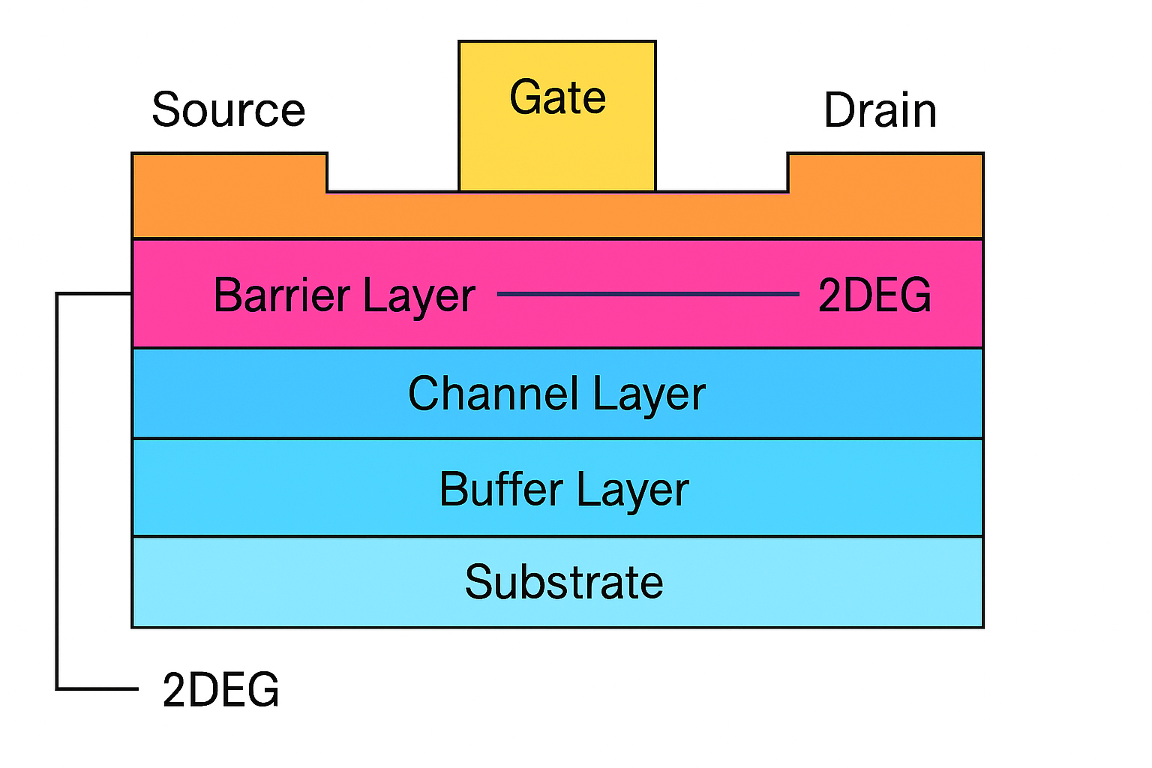

**Figure 3.1** HEMT Structure

The architecture of a HEMT consists of a stacked arrangement of semiconductor materials intended to enhance rapid electron transport through a 2DEG. A standard HEMT starts with a substrate at its foundation, typically made from materials like silicon (Si), sapphire, or silicon carbide (SiC) or high-resistivity silicon, with selections made based on a balance of performance and cost. Positioned above the substrate is a buffer layer, generally formed of Gallium Nitride (GaN). This layer acts as a transitional medium that accommodates the lattice mismatch between the substrate and the upper active layers. It also plays a role in minimizing defect propagation into the channel layer, thus maintaining the device's electronic integrity. Additionally, the buffer may serve as an electrical isolation zone to prevent leakage currents from the substrate.

The undoped GaN channel layer is situated directly above the buffer layer. This layer is crucial for the operation of HEMTs, as it is where the two-dimensional electron gas (2DEG) forms. Unlike traditional semiconductors that need deliberate doping to establish conductive pathways, the HEMT’s 2DEG emerges at the junction of the GaN channel and the barrier layer as a result of polarization effects. These effects consist of spontaneous polarization (which is intrinsic to the crystal structure) and piezoelectric polarization (caused by strain), which collectively generate a high-density electron sheet at the heterojunction.

The barrier layer, typically consisting of a thin film of Aluminium Gallium Nitride (AlGaN), is deposited over the GaN channel. This layer's primary role is to induce and confine the 2DEG at the GaN/AlGaN interface. An increase in the aluminium content in AlGaN results in a greater polarization difference, thereby enhancing the induced electron density in the 2DEG. Frequently, a very thin spacer layer made of undoped AlN or GaN is placed between the AlGaN and GaN layers to reduce scattering and enhance electron mobility.

On the surface of the AlGaN barrier layer, metallic contacts are established to create the transistor terminals: the source, drain, and gate. The source and drain are generally constructed from low-resistance ohmic contacts. These contacts facilitate the efficient flow of electrons into and out of the 2DEG channel. In contrast, the gate is commonly a Schottky metal contact (such as Ni/Au) that regulates the electron flow within the channel by managing the electrostatic field across the barrier layer. By applying various gate voltages. A simplified diagram demonstrating this structure is presented in Figure 3.1.

**Depletion Type MODFET :**

A depletion-mode MODFET (Modulation-Doped Field Effect Transistor) is a fast semiconductor device that has a conducting channel even in the absence of gate bias. It utilizes a heterostructure to form a two-dimensional electron gas (2DEG) with excellent mobility. By applying a negative gate voltage, carrier concentration is reduced, resulting in decreased current flow and enabling accurate electronic control.

**Enhancement Type MODFET :**

An enhancement-mode MODFET (Modulation-Doped Field Effect Transistor) typically remains non-conductive in the absence of gate voltage. It employs a heterostructure to create a high-mobility two-dimensional electron gas (2DEG) when a positive gate voltage is introduced, which generates carriers within the channel. This type of device provides rapid performance, minimal noise, and effective control in microwave and high-frequency applications.

**3.3 OPERATION OF AlGaN/GaN HEMT**

The functioning of an AlGaN/GaN High Electron Mobility Transistor (HEMT) relies on the management of current through a high-mobility electron channel that is established at the interface between Aluminium Gallium Nitride (AlGaN) and Gallium Nitride (GaN). Unlike conventional MOSFETs, which depend on doped areas for conduction, the AlGaN/GaN HEMT uses spontaneous and piezoelectric polarization to create a two-dimensional electron gas (2DEG) at the heterojunction without the need for intentional doping. This 2DEG serves as the primary pathway for current flow and offers enhanced electron mobility by minimizing impurity scattering. The device features three main terminals: source, drain, and gate. Current moves from the source to the drain, while the gate voltage (VGS) regulates this flow by altering the 2DEG density below the gate.

**3.3.1 Off-State Operation**

In the off-state, a sufficiently negative gate voltage is applied, which reduces the 2DEG channel underneath the gate area. The electric field produced by the negative VGS causes electrons to be repelled, thereby lowering or significantly diminishing carrier concentration in the channel. Consequently, the drain current (ID) nearly approaches zero, effectively switching the transistor off. This represents the device's non-conductive state. The threshold voltage (VT) is critical in this context—it indicates the minimum gate voltage necessary to initiate the formation of a conductive channel. When VGS is below this threshold, the 2DEG is depleted, preventing current flow.

**3.3.2 Linear Region**

As VGS rises and surpasses the threshold, the device enters the linear region. During this state, a partial 2DEG channel develops, and a small drain-source voltage (VDS) enables current to flow from the source to the drain. In this region, ID increases linearly with VDS, causing the transistor to act like a voltage-controlled resistor. The current in this phase is affected by both the gate voltage and the drain voltage. The linear region is crucial for analog applications that require signal amplification.

**3.3.3 Saturation Region**

As VDS is further increased and surpasses the overdrive voltage (VDS > VGS − VT), the device shifts into the saturation region. At this stage, the electric field near the drain becomes sufficiently strong to locally deplete the 2DEG, resulting in a pinch-off condition. The current no longer rises linearly with VDS and instead stabilizes, reaching a nearly constant maximum level. In this region, ID is primarily influenced by VGS, with changes in VDS having minimal impact on the output current.

**3.4 KEY PARAMETERS AND EQUATIONS OF AlGaN/GaN HEMT**

To gain a comprehensive understanding of the AlGaN/GaN High Electron Mobility Transistor (HEMT), it is crucial to examine several key physical parameters and the equations that dictate their functionality. These parameters not only characterize the electrical performance of the device but also assist in its design, optimization, and simulation. Specifically, elements such as charge concentration, threshold voltage, drain current, and transconductance provide valuable insights into how a HEMT operates under different conditions.

**3.4.1 Two-Dimensional Electron Gas (2DEG) Sheet Density (ns)**

The core of HEMT lies in the creation of a high-mobility 2DEG at the AlGaN/GaN heterointerface. This charge layer arises from polarization effects instead of doping, which leads to enhanced mobility and lower scattering. The sheet carrier concentration **​ns**, is influenced by the gate voltage and can be expressed as

(3.1)

In this equation **𝜀I**denotes the dielectric constant of the AlGaN barrier, **𝑑𝑖** indicates its thickness, **𝑉𝑔​** refers to the applied gate voltage, and **Δϕ** represents the conduction band bending as a result of polarization. This relationship demonstrates that as **𝑉𝑔** becomes increasingly positive, the 2DEG density rises, which improves conductivity in the channel. The ability to control **𝑛𝑠​** in this manner enables precise gate regulation over the channel.

**3.4.2 Threshold Voltage (VT)**

The threshold voltage (**VT**) is the gate voltage at which the 2DEG channel starts to conduct a significant amount of current. This parameter is essential for understanding the switching characteristics and the behaviour of the HEMT in normally-on/off configurations.

The formula for **VT** includes various physical properties of the device

(3.2)

where, **𝜙𝐵**​ represents the Schottky barrier height at the interface between the gate metal and the AlGaN layer, **ΔEC** denotes the conduction band discontinuity at the heterojunction, **𝑁𝐷**​ indicates the background doping level in GaN, while **𝑑** and **ε** signify the barrier thickness and permittivity, respectively. A more negative **𝑉𝑇** ​ suggests a depletion mode device, while making **𝑉𝑇** approach zero allows for enhancement-mode functionality, which is considered safer and favoured in power electronics.

**3.4.3 Drain Current in the Linear Region**

When the HEMT operates in its linear or ohmic region, the drain current (**ID**) rises in direct proportion to **VDS**, causing the device to function as a voltage-controlled resistor. This behaviour is represented by:

(3.3)

In this context, **μ** represents the electron mobility in the 2DEG. The term **𝐶𝑔** denotes the gate capacitance per unit area, while **𝑊**  is width and **𝐿** is length of the gate.

**3.4.4 Drain Current in the Saturation Region**

When the **𝑉𝐷𝑆** exceeds the saturation threshold (which means 𝑉𝐷𝑆 > 𝑉𝐺𝑆 − 𝑉𝑇), the channel gets pinched off close to the drain, and **𝐼𝐷** reaches a saturation level. The current in this region is expressed as:

(3.4)

This equation presumes that the device operates under a square-law relationship similar to MOSFETs in the long-channel operation. The saturation region plays a crucial role in digital switching and RF power amplification, where a consistent and high output current is necessary despite variations in **VDS**.

**3.4.5 Transconductance (𝑔𝑚**)

Transconductance, represented as **𝑔𝑚**, is an important metric for evaluating the amplification ability of a transistor. It quantifies how much **𝐼𝐷** varies when there is a change in **𝑉𝐺𝑆** and is given by the following expression:

(3.5)

Higher **𝑔𝑚** values indicate stronger control of the gate over the channel, which translates into better gain in RF circuits and amplifiers.

**3.4.6 Output Conductance (𝑔𝑑𝑠)**

Output conductance, denoted as **𝑔𝑑𝑠**, indicates the extent to which the drain current varies in relation to **𝑉𝐷𝑆** within the saturation region.

(3.6)

An optimal HEMT would display a zero value for **𝑔𝑑𝑠**, which signifies ideal current saturation; however, actual devices show a small yet non-zero output conductance. Reducing **𝑔𝑑𝑠** enhances signal stability and efficiency in high-frequency applications.

**3.5 ENERGY BAND AND 2DEG FORMATION IN AlGaN/GaN** **HEMTs**

Understanding the functionality of AlGaN/GaN HEMT starts with analysing the energy band alignment at the interface of the heterojunction. A standout characteristic of this device is the generation of a 2DEG, which is a result of the intrinsic variations in the material properties of Aluminium Gallium Nitride (AlGaN) and Gallium Nitride (GaN). The theoretical framework of this effect is represented in the energy band diagram depicted in Figure 3.2.

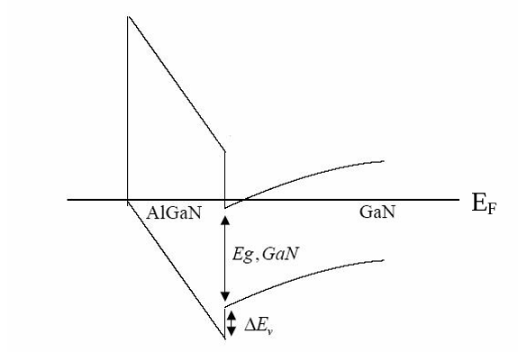

**Figure 3.2** Bandgap diagram of AlGaN/GaN HEMT

At the core of the AlGaN/GaN HEMT lies a heterojunction configuration, where a thin AlGaN layer is layered at the top of GaN channel layer. These materials exhibit significantly different bandgap energies—AlGaN has a larger bandgap when compared to GaN. This discrepancy results in sudden alterations, or offsets, in both the conduction and valence bands at the junction. In particular, the conduction band discontinuity (ΔEC) is crucial in capturing free electrons at the interface, facilitating the creation of a confined electron layer, the 2DEG, in the GaN.

The band alignment illustrated in Figure 3.2 shows electrons are energetically inclined to pile up in the lower conduction band of GaN, situated beneath the AlGaN barrier. This accumulation results in the establishment of a quantum well, wherein electrons are confined to a narrow, planar region with restricted vertical movement without the need for intentional doping, which is beneficial as it reduces impurity scattering and optimizes carrier mobility.

The position of the Fermi level (**EF**) in the band diagram validates the existence of a conductive channel, even without an applied gate bias. The Fermi level sits above the conduction band edge in the GaN layer, signifying that the channel is inherently occupied by electrons under equilibrium conditions.

Moreover, the aluminium concentration in the AlGaN barrier has a significant impact on the band structure. Increasing the aluminium content amplifies the conduction band offset and polarization effects, thus augmenting the 2DEG sheet density. However, this must be finely balanced, as too much aluminium can result in elevated gate leakage currents and diminished device reliability.

The gate terminal within the HEMT architecture, typically a Schottky contact, regulates the 2DEG density. By applying a negative voltage across the gate, the conduction band is elevated, ultimately depleting the 2DEG below. This gate control mechanism enables the device to efficiently alternate between on and off states, which is a fundamental aspect of HEMT performance.

In summary, the band diagram in Figure 3.2 not only emphasizes the fundamental physics of the AlGaN/GaN heterojunction but also demonstrates how the 2DEG is inherently formed and regulated within the device. The pronounced polarization effects and advantageous band offsets are key to the enhanced high-frequency and high-power capabilities of these devices.

# CHAPTER 4

**DEVICE MODELING OF AlGaN/GaN HEMT IN SILVACO**

This chapter presents Silvaco TCAD (Technology Computer-Aided Design), a popular tool for simulating semiconductor devices that enables researchers to model, simulate, and analyse the electrical properties of sophisticated semiconductor structures. It begins by outlining the capabilities of Silvaco TCAD and its significance in contemporary device engineering. Following that, it describes the specific AlGaN/GaN HEMT structure developed and simulated with the software[20], including the materials, layers, and parameters incorporated into the modeling.

The simulation yields critical output characteristics such as the drain current–voltage (I-V) relationship, which offers insights into the operational performance of the device. These findings not only confirm the theoretical comprehension of HEMT behaviour but also assist in the further enhancement of device design. The chapter connects theoretical concepts with practical application, emphasizing how simulation tools can expedite advancements in semiconductor research.

**4.1** **INTODUCTION TO SILVACO**

The model for the AlGaN/GaN HEMT created in this study was designed and simulated using the Silvaco TCAD software suite. This platform provides an extensive array of tools specifically formulated for simulating complex semiconductor devices, particularly those that involve compound materials such as group III-V semiconductors. The modeling process commenced in **DeckBuild**, which is both a graphical and command-line interface that allows users to create and manage simulation input files. These files encompass all the physical specifications of the device, including its geometry, material layers, doping profiles, and electrical contacts.

Simulations were carried out utilizing **ATLAS**, which is the primary device simulator from Silvaco. ATLAS addresses fundamental semiconductor equations on a two- or three-dimensional mesh that is applied to the established device structure. It incorporates drift-diffusion and continuity equations, which facilitate a precise prediction of charge carrier behaviour under various biasing conditions. For the analysis of the graphical output and the extraction of key parameters from the simulation outcomes, **TonyPlot** Silvaco’s visualization tool, was employed.

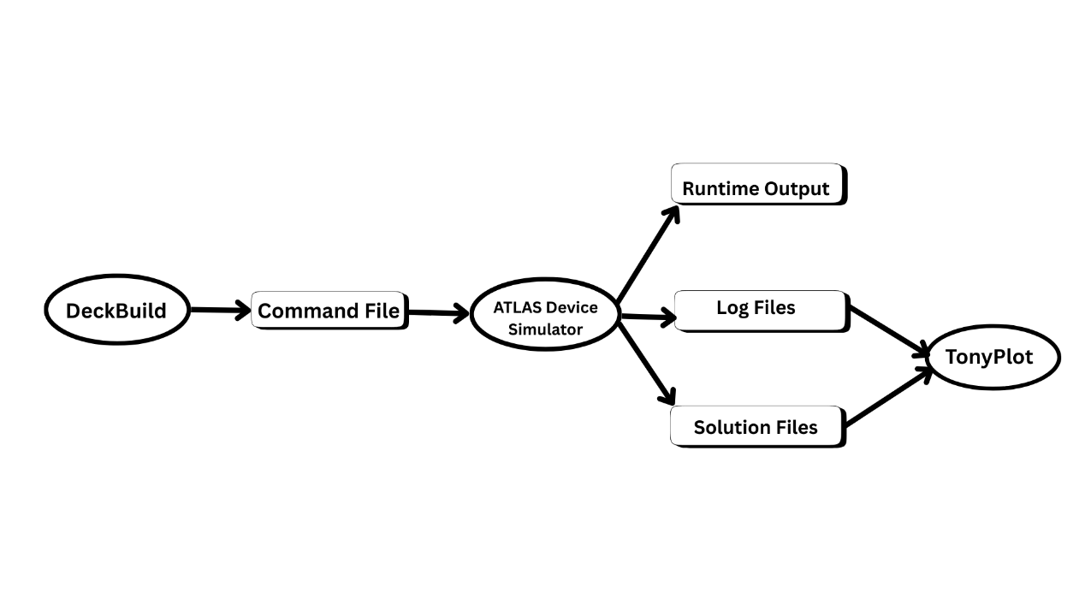

**Figure 4.1** Silvaco Simulation Flowchart

**4.2 SIMULATION WORKFLOW IN ATLAS**

Establishing a device simulation in ATLAS requires adhering to a clearly defined sequence of commands. Through several iterations, we recognized the significance of following this order diligently. Even missing a boundary condition could result in errors or produce outcomes that do not accurately represent the device's behaviour.

**4.2.1 Structure Definition**

We started by defining the physical structure of the device. By utilizing essential commands such as **mesh**, **region**, **electrode**, and **doping**, we illustrated the geometric grid, designated materials, and appropriately positioned electrodes.

**4.2.2 Material and Model Configuration**

After establishing the physical layout, we moved on to assign material characteristics and activate the necessary physical models. Commands like **material**, **models,** and interface were vital in this step. For an AlGaN/GaN HEMT, it was particularly important to include polarization effects and high-field mobility models.

**4.2.3 Numerical Method Selection**

At this stage, we configured the settings for the numerical solver using the method command. While the default settings sufficed for less complex scenarios, more sophisticated simulations needed meticulous adjustments.

**4.2.4 Simulation Execution**

With the structure and models established, we set the operating conditions and commenced the simulations. This required commands like **log**, **solve**, **load**, and **save**. Depending on our analysis goals, whether they involved output characteristics, transfer curves, or thermal responses, we conducted various bias sweeps and stored intermediate states for additional examination.

**4.2.5 Data Extraction and Visualization**

In the final step, we evaluated the results using commands to collect parameters like Drain current, drain to Source voltage, Gate voltage, transconductance. For graphical interpretation, we utilized **TonyPlot**, which proved useful for reviewing band diagrams, carrier densities, and field distributions.

**4.3 SIMULATION OF HEMT STRUCTURE USING SILVACO ATLAS**

In this research, we created a high electron mobility transistor (HEMT) utilizing an AlGaN/GaN heterostructure, which was modeled and simulated within the Silvaco ATLAS environment. The structure was meticulously designed with a vertical multi-layer stack on a sapphire substrate. The simulation parameters, including geometry, material specifications, doping levels, and electrode arrangements, were implemented using ATLAS command syntax.

The device consists of four primary layers. At the bottom, a sapphire layer with a thickness of 1000 nm acts as the insulating substrate (Region 1). On top of this, there is a 20 nm thick AlN layer (Region 2), serving typically as a buffer or nucleation layer to manage lattice mismatch and enable high-quality GaN epitaxy.

The GaN layer, which is 1948 nm thick (Region 3), constitutes the main channel of the device where the two-dimensional electron gas (2DEG) is anticipated to develop. Above this channel is a 32 nm AlGaN barrier layer (Region 4) with varying aluminium mole fraction, which enhances polarization effects essential for 2DEG formation without intentional doping of the channel.

The device's lateral configuration includes three terminals: the source and drain electrodes each measure 500 nm in width and are positioned at the device's edges, while the gate electrode is 2000 nm wide and centrally located in between them. All electrodes are defined on the top surface and connected to the AlGaN layer, following the mesh and electrode commands.

The AlGaN region (Region 4) is uniformly doped with n-type carriers at a concentration of 1.5 × 10¹⁸ cm⁻³, guaranteeing a sufficient carrier supply for conduction. The electrical contacts are modeled with specific work functions: 3.93 eV for both the source and drain, and 5.0 eV for the gate, to accurately reflect the barrier behaviour and electron injection characteristics.

This simulation also incorporates models such as Shockley-Read-Hall recombination, polarization effects (with strain-induced polarization scaling set to 0.8), and field-dependent mobility employing the Albrecht model. These models account for significant physical mechanisms influencing carrier transport in III-nitride HEMTs.

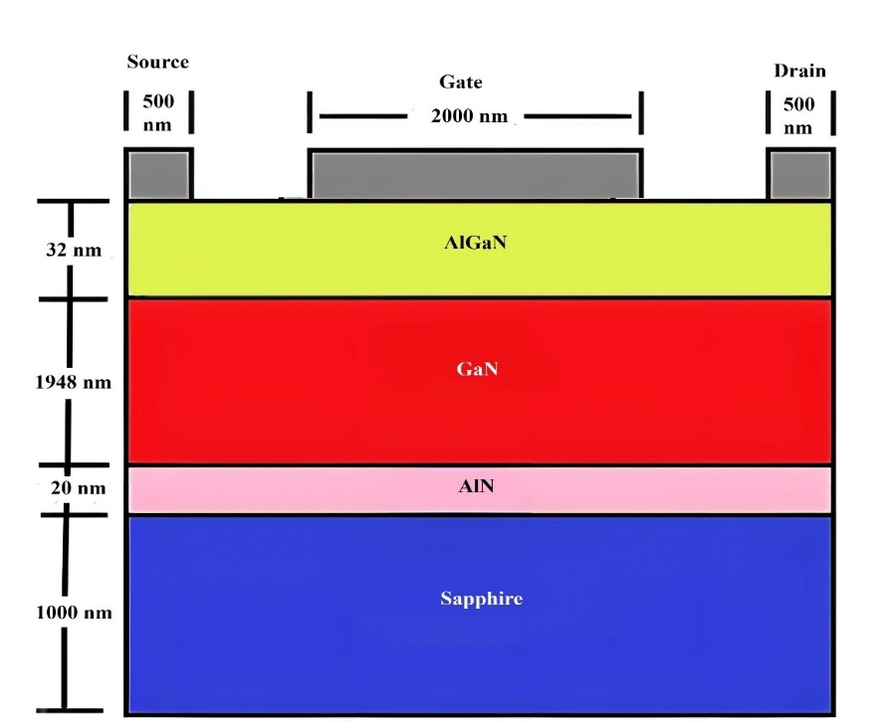

**Figure 4.2** Schematic Representation of an AlGaN/GaN double Heterojunction HEMT Structure Featuring a 32 nm AlGaN Barrier and

a Fixed Gate Length of 2000 nm

**4.4 VARIATION OF HEMT CHARACTERISTICS WITH DESIGN PARAMETERS**

The V–I characteristics of AlGaN/GaN HEMTs are significantly influenced by variables such as AlGaN thickness, aluminium mole fraction, and doping levels. Increasing the thickness of AlGaN boosts the polarization-induced electric field at the heterojunction, which increases the 2DEG density and enhances the drain current and transconductance. However, if the thickness becomes too great, it can lead to an unfavourable shift in the threshold voltage. A higher aluminium mole fraction also elevates the 2DEG density by strengthening polarization; however, excessive

aluminium content can compromise interface quality and reliability. Doping levels play a crucial role as well moderate doping enhances carrier control, while excessive doping can lead to increased leakage and diminished performance. In summary, precise adjustment of these parameters is vital for optimizing current drive, threshold control, and device stability.

**4.4.1 Effect of AlGaN Thickness On I-V Characteristics**

The thickness of the AlGaN barrier layer in a HEMT structure is vital in influencing it’s I-V characteristics, especially in region 4 of the device. As the thickness of the AlGaN layer increases, the polarization effects at the AlGaN/GaN interface become more pronounced, leading to a stronger electric field and an increased density of the two-dimensional electron gas (2DEG). This growth in 2DEG density enhances channel conductivity, resulting in a noticeable rise in the drain current for a given gate-source voltage. Additionally, the threshold voltage generally shifts negatively with an increase in AlGaN thickness, suggesting a move towards normally-on behaviour. While this can be advantageous for high-frequency performance due to improved transconductance, excessive thickness may lead to increased short-channel effects and potential degradation in material quality as a result of strain relaxation.

**4.4.1.1 Effect of Thickness on Output Characteristics (IDS - VDS)**

As the thickness of the AlGaN layer in a High Electron Mobility Transistor (HEMT) increase, the drain characteristics tend to enhance because of increased polarization-induced charge at the AlGaN/GaN interface. This results in a higher density of the two-dimensional electron gas (2DEG), which boosts the channel conductivity and the ability to carry current. Nonetheless, after reaching a specific thickness, the strain within the AlGaN layer may relieve, leading to defects that can impair device performance, reduce electron mobility, and contribute to leakage currents. Therefore, while moderate increases in AlGaN thickness can enhance output current and transconductance, excessive thickness may adversely affect the reliability and efficiency of the device.

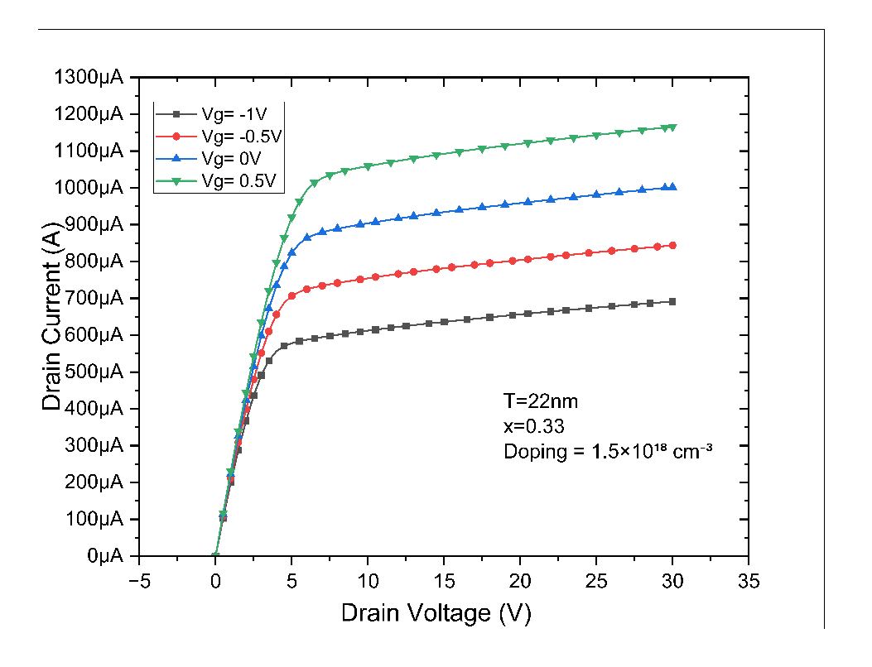

**Figure 4.3** Drain characteristics of AlGaN/GaN HEMT with AlGaN barrier thickness of 22 nm, Al mole fraction x=0.33, and doping concentration 1.5×1018 cm−3

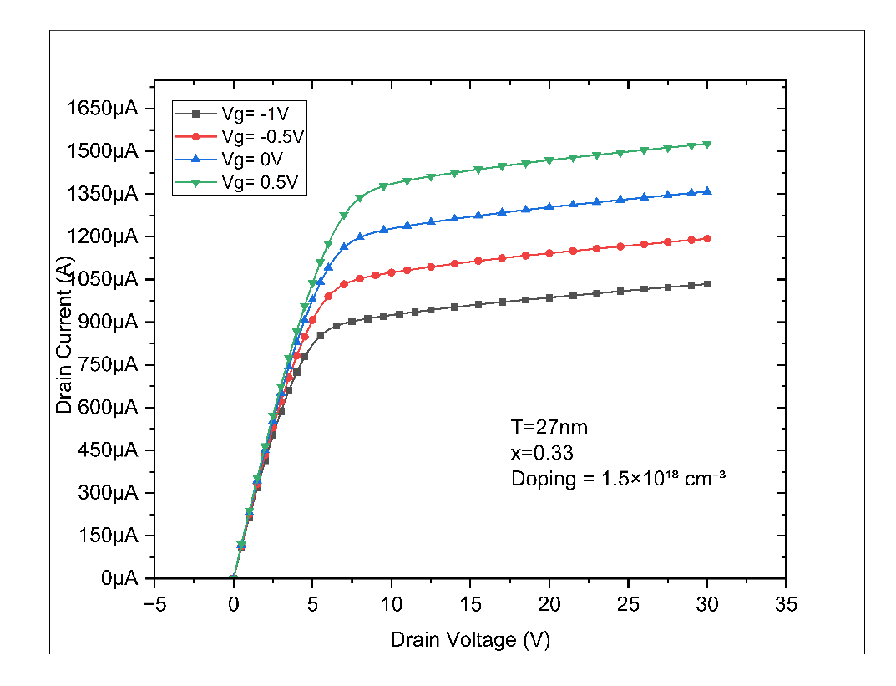

**Figure 4.4** Drain characteristics of AlGaN/GaN HEMT with AlGaN barrier thickness of 27 nm, Al mole fraction x=0.33, and doping concentration 1.5×1018 cm−3.

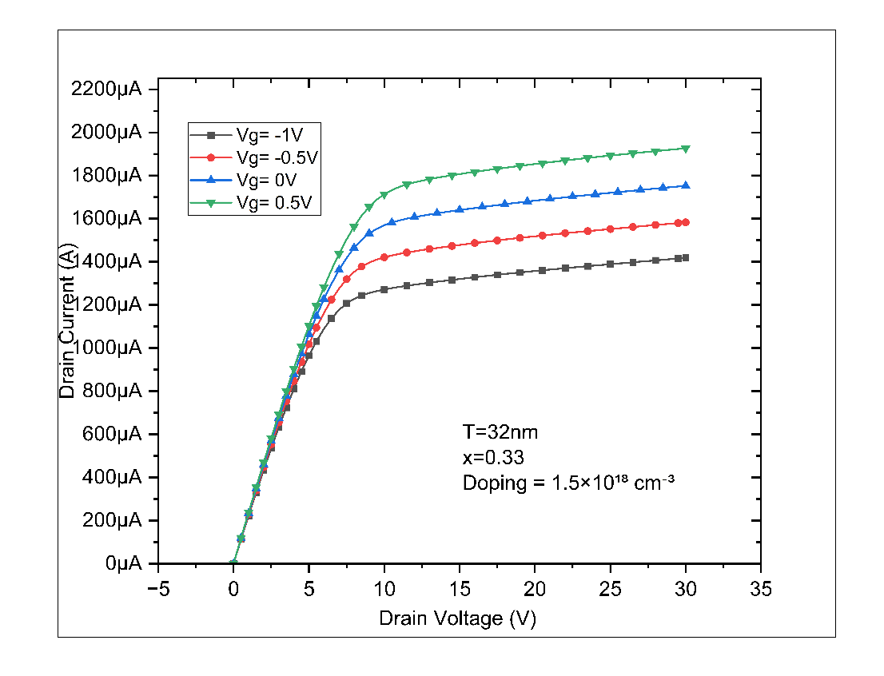

**Figure 4.5** Drain characteristics of AlGaN/GaN HEMT with AlGaN barrier thickness of 32 nm, Al mole fraction x=0.33, and doping concentration 1.5×1018 cm−3.

The drain characteristics of the HEMT vary noticeably with the thickness of the AlGaN layer. As the thickness increases from 22 nm to 32 nm, the drain current (ID) rises significantly due to the increased 2DEG density at the interface, enhancing channel conductivity. The device with 32 nm thickness shows the highest current levels, indicating better electron confinement and improved transconductance. Overall, thicker AlGaN layers improve output performance up to a point, as demonstrated by the higher currents in the 32 nm sample compared to thinner layers.

**4.4.1.2 Effect of Thickness on Transfer Characteristic (IDS – VGS)**

In a HEMT the transfer characteristic describes the relationship between the drain-source current (IDS) and the gate-source voltage (VGS). This characteristic essentially illustrates how well the gate can regulate the current flowing through the channel, which is crucial for the device’s amplification and switching behaviour.

A significant factor affecting this relationship is the thickness of the barrier layer, which is usually AlGaN in AlGaN/GaN HEMT. As the thickness of the barrier layer increases, the quantity of charge that can accumulate at the heterojunction interface 2DEG, develops also varies. A thicker barrier can enhance polarization effects, resulting in stronger 2DEG confinement and increased carrier density but only up to a certain point. This often leads to a higher IDS for a given VGS, effectively causing the transfer characteristic to shift upwards.

However, if the barrier layer becomes excessively thick, it might lead to heightened scattering or defects, which can diminish mobility or weaken gate control. This could result in a less steep IDS–VGS curve and lower gate modulation efficiency.

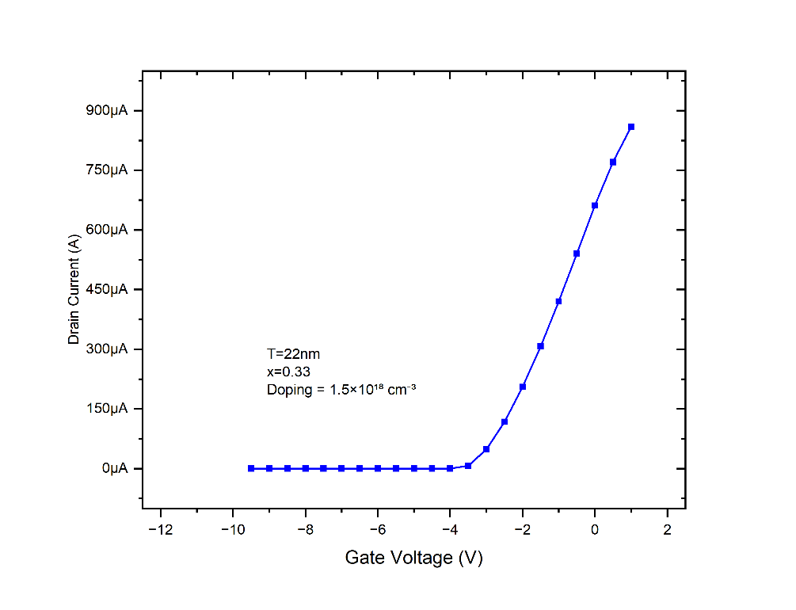

**Figure 4.6** Variation of Drain Current with Gate Voltage for Thickness 22 nm and Al Mole Fraction of 0.33, with Doping Concentration of 1.5×10¹⁸ cm⁻³.

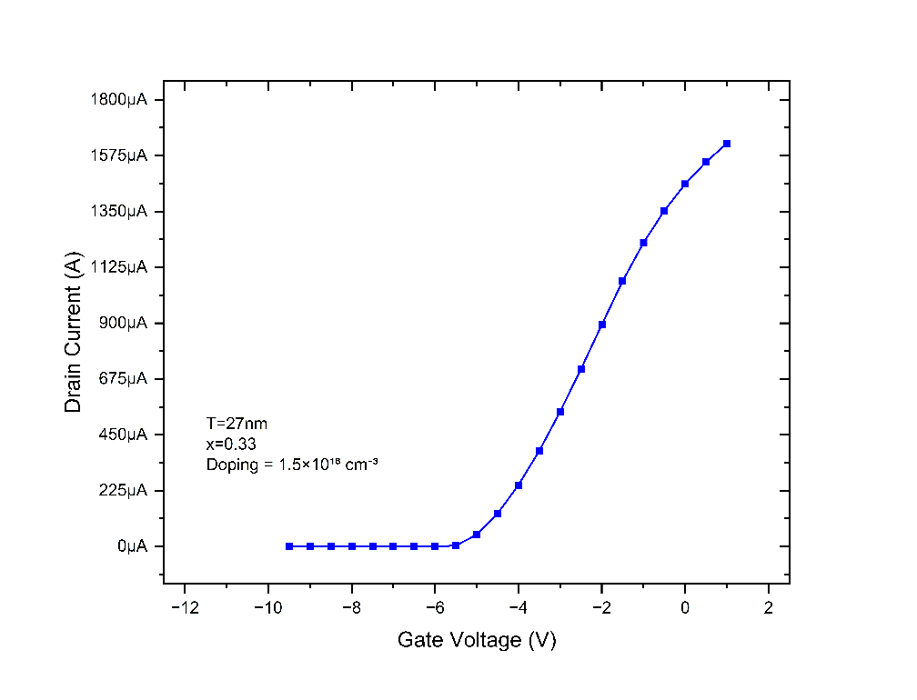

**Figure 4.7** Variation of Drain Current with Gate Voltage for Thickness 27 nm and Al Mole Fraction of 0.33, with Doping Concentration of 1.5×10¹⁸ cm⁻³.

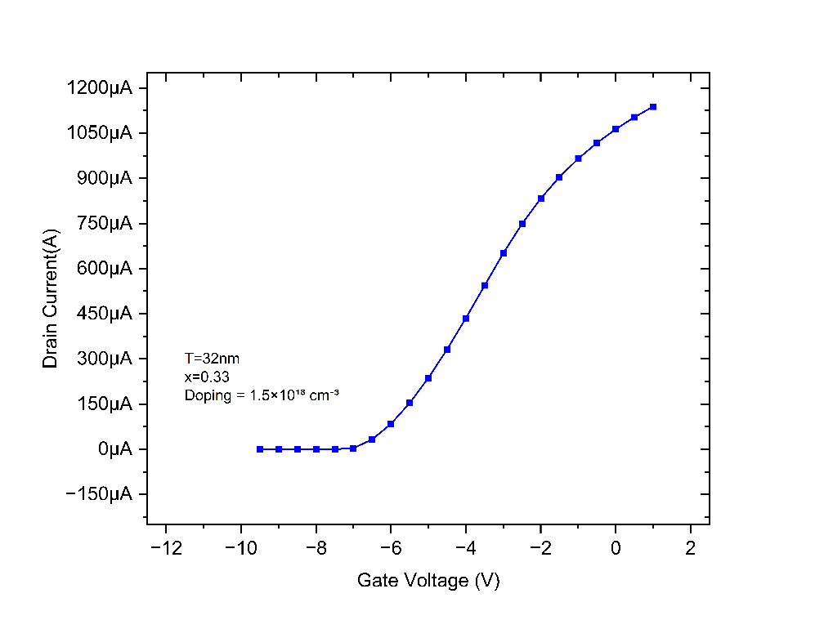

**Figure 4.8** Variation of Drain Current with Gate Voltage for Thickness 32 nm and Al Mole Fraction of 0.33, with Doping Concentration of 1.5×10¹⁸ cm⁻³.

In AlGaN/GaN HEMTs, the thickness of the AlGaN barrier layer significantly influences the device's transfer characteristics (IDS–VGS). As the barrier thickness increases, the polarization-induced charges at the AlGaN/GaN interface rise, boosting the density of the two-dimensional electron gas (2DEG) and elevating the drain current when there is zero gate bias. As a result, the threshold voltage (VTH) shifts to more negative values, necessitating a greater negative gate voltage to completely deplete the channel, which has a direct effect on the device's switching performance and gate control efficiency.

**4.4.2 EFFECT OF MOLE FRACTION ON I-V CHARACTERISTICS**

The aluminium mole fraction within the AlGaN layer is crucial for shaping the I–V characteristics of HEMTs. An increase in mole fraction boosts the polarization-induced electric field at the AlGaN/GaN interface, subsequently raising the density of the (2DEG). A higher density of 2DEG enhances channel conductivity, leading to a significant rise in drain current for a given gate and drain voltage. This improvement translates into increased transconductance and overall better performance of the device, especially in high-frequency settings. A very high Al mole fraction can also alter the threshold voltage and impact device stability. Thus, while elevating the aluminium mole fraction can greatly enhance output characteristics, careful optimization is necessary to prevent compromising device stability and long-term performance.

**4.4.2.1 Effect of Mole fraction on Output Characteristics (IDS - VDS)**

The amount of Al in the AlGaN layer significantly affects the drain characteristics (ID-VDS) of AlGaN/GaN HEMTs. An increase in mole fraction boosts polarization at the AlGaN/GaN interface, resulting in a higher density 2DEG. This leads to enhanced channel conductivity and increased IDS for a specific VDS. However, a high Al concentration can lead to lattice mismatch, compromising interface quality and diminishing mobility. It can also alter the VTH and impact device stability. Thus, finding an optimal mole fraction is crucial for high-frequency HEMT applications.

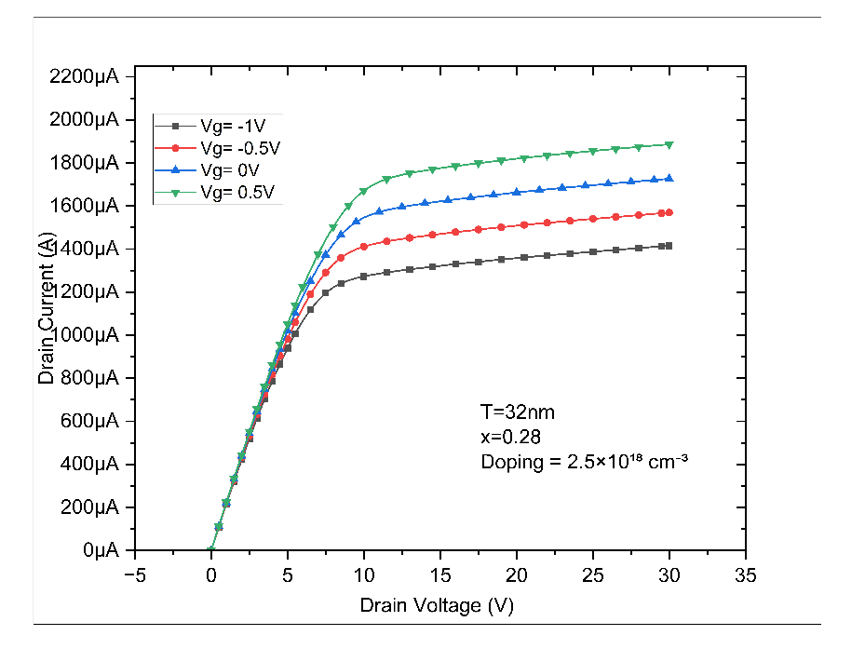

**Figure 4.9** Drain characteristics of AlGaN/GaN HEMT with AlGaN barrier thickness of 32 nm, Al mole fraction x=0.28, and doping concentration 2.5×1018 cm−3.

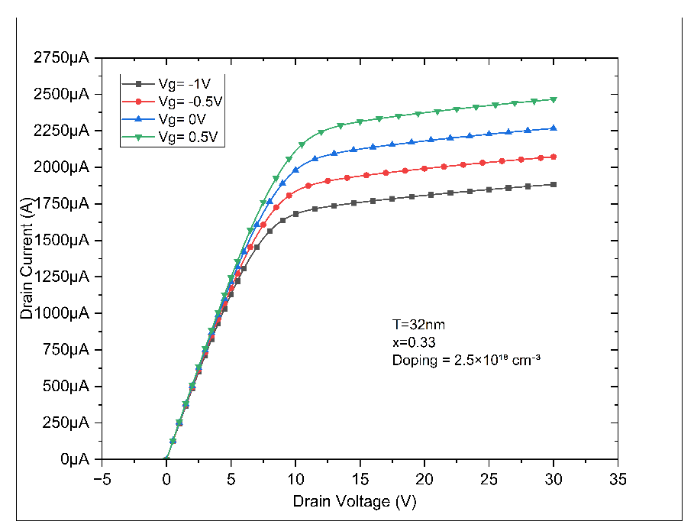

**Figure 4.10** Drain characteristics of AlGaN/GaN HEMT with AlGaN barrier thickness of 32 nm, Al mole fraction x=0.33, and doping concentration 2.5×1018 cm−3.

By maintaining the AlGaN thickness at 32 nm and a doping concentration of 2.5×10¹⁸ cm⁻³, an increase in the Al mole fraction from 0.28 to 0.33 led to a significant rise in the drain current observed in the ID-VDS characteristics. This enhancement is due to the stronger polarization effects for higher mole fractions, which boost the density of the 2DEG at the AlGaN/GaN interface. This trend indicates that higher aluminium content improves performance but needs to be optimized to prevent interface degradation.

**4.4.2.2 Effect of Mole fraction on Transfer Characteristic (IDS – VGS)**

In AlGaN/GaN HEMTs, the amount of aluminium in the AlGaN barrier has a significant impact on the transfer characteristics (IDS–VGS). Increasing the aluminium fraction boosts the polarization effects at the AlGaN/GaN interface, resulting in a higher density of the two-dimensional electron gas (2DEG). This increase contributes to a greater drain current at zero gate voltage and causes the threshold voltage (VTH) to shift negatively. Consequently, the device necessitates a larger negative gate voltage for an effective turn-off, which influences current regulation, switching performance, and the overall functionality of the device.

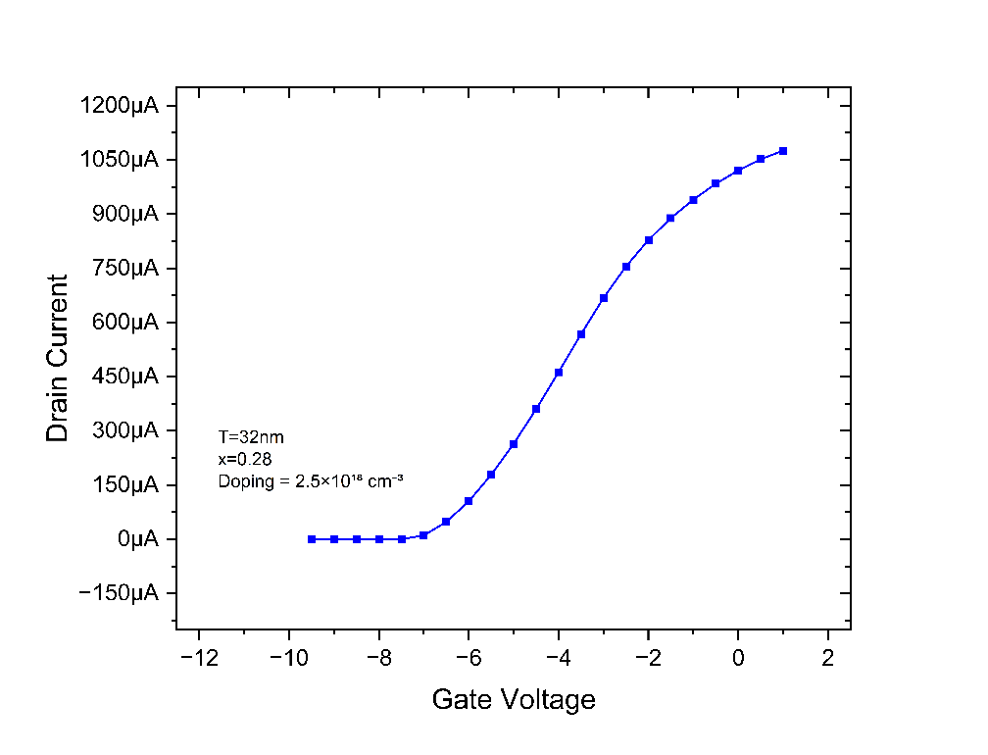

**Figure 4.11** Variation of Drain Current with Gate Voltage for T = 32 nm and Al Mole Fraction of 0.28, with Doping Concentration of 2.5×10¹⁸ cm⁻³.

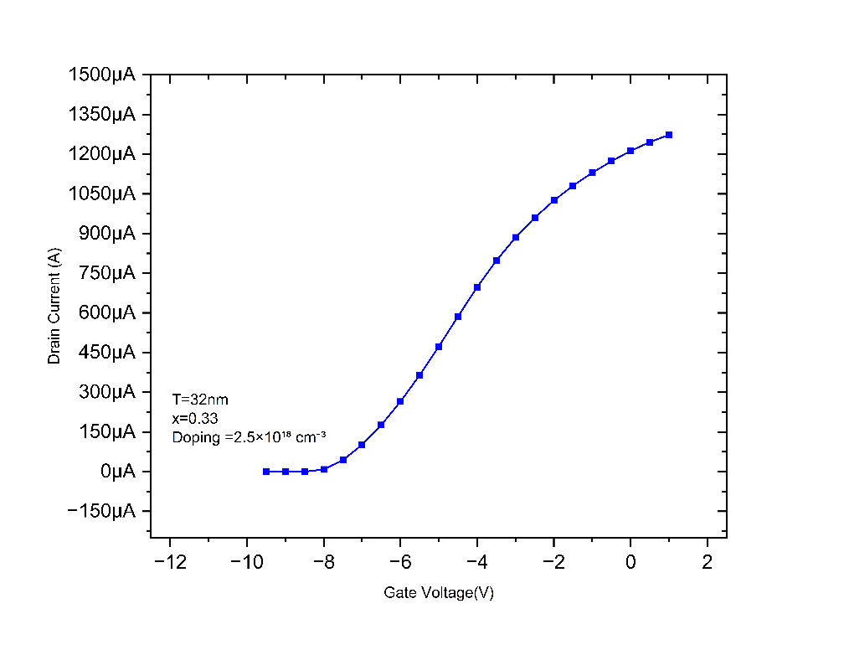

**Figure 4.12** Variation of Drain Current with Gate Voltage for T = 32 nm and Al Mole Fraction of 0.33, with Doping Concentration of 2.5×10¹⁸ cm⁻³.

In the results of the simulated AlGaN/GaN HEMT, an increase in the aluminium mole fraction of the AlGaN barrier layer from 0.28 to 0.33 causes a significant change in the threshold voltage (VTH). Specifically, the threshold voltage shifts from around –7 volts to –8 volts. This negative shift is attributed to the increased aluminium content, which enhances the polarization-induced charge at the AlGaN/GaN interface, thereby raising the density of the two-dimensional electron gas (2DEG). Consequently, a more negative gate voltage is necessary to completely deplete the channel and turn off the device, which directly influences the transfer characteristics and device control behaviour.

**4.4.3 EFFECT OF DOPING CONCENTRATION VARIATION ON I-V CHARACTERISTICS**

The doping concentration within the AlGaN/GaN HEMT structure significantly influences it’s I–V characteristics. By modifying the doping level—especially in the barrier or buffer layer—the device's carrier concentration and electrostatic control can be precisely adjusted. An increase in doping concentration results in a greater availability of free carriers, which boosts the density of the two-dimensional electron gas (2DEG) at the AlGaN/GaN interface. This enhancement leads to improved channel conductivity and increased drain current for a specific gate and drain bias. However, if the doping level becomes too high, it can increase impurity scattering, lower carrier mobility, and introduce leakage currents, which may ultimately compromise device reliability and thermal stability. Furthermore, elevated doping levels can alter the threshold voltage, which may change the switching behaviour of the device. Typically, the resulting I–V curves exhibit steeper slopes and increased saturation currents with moderate increases in doping. Consequently, optimizing the doping concentration is essential for achieving a balance between performance, efficiency, and long-term stability in HEMT operation.

**4.4.3.1 Effect of Doping Concentration on Output Characteristics (IDS - VDS)**

The doping concentration in AlGaN/GaN HEMTs has a direct impact on the drain characteristics (**ID - VDS** )by altering the carrier density and the distribution of the electric field within the device. Raising the doping level, particularly in the barrier or buffer layer, promotes the formation of a two-dimensional electron gas (2DEG) at the heterojunction, which decreases channel resistance and increases drain current. This leads to steeper **ID - VDS** curves and enhanced output performance. However, excessively high doping levels can cause increased impurity scattering and leakage currents, which can adversely affect mobility and reliability. Therefore, finding an optimal doping level is crucial for balancing current drive, efficiency, and the stability of the device.

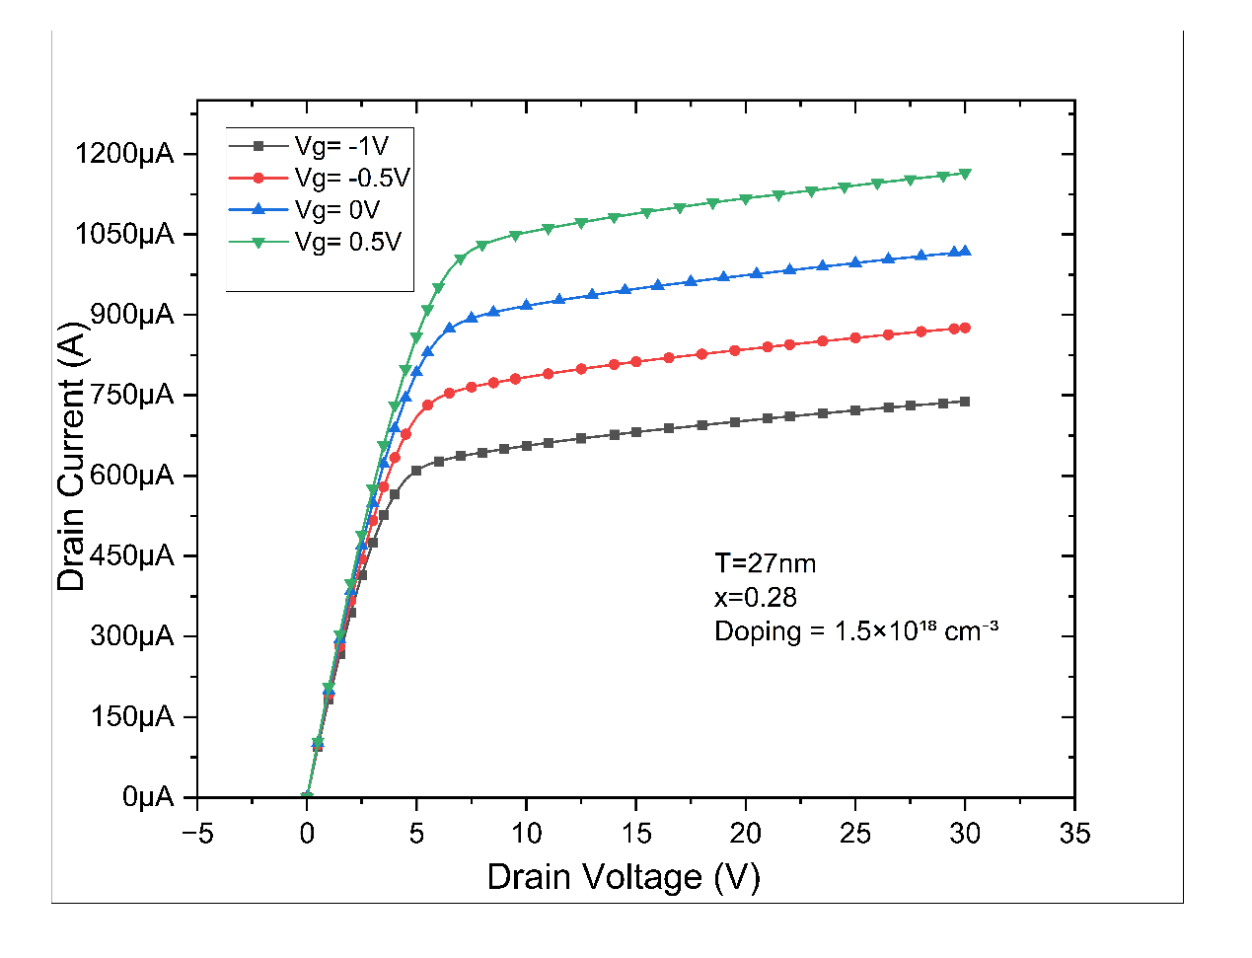

**Figure 4.13** Drain characteristics of AlGaN/GaN HEMT with AlGaN barrier thickness of 27 nm, Al mole fraction x=0.28, and doping concentration 1.5×1018 cm−3.

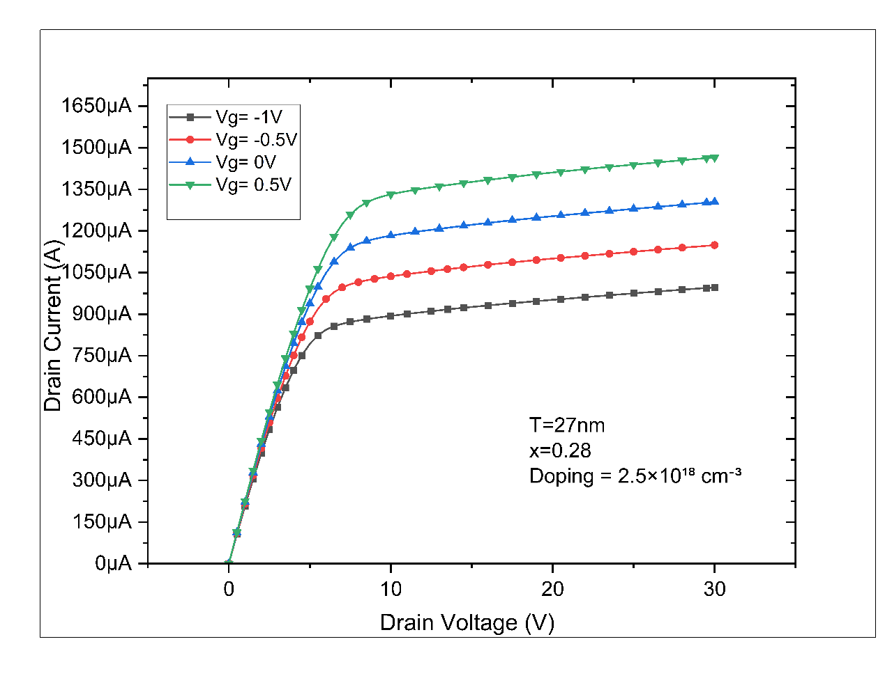

**Figure 4.14** Drain characteristics of AlGaN/GaN HEMT with AlGaN barrier thickness of 27 nm, Al mole fraction x=0.28, and doping concentration 2.5×1018 cm−3.

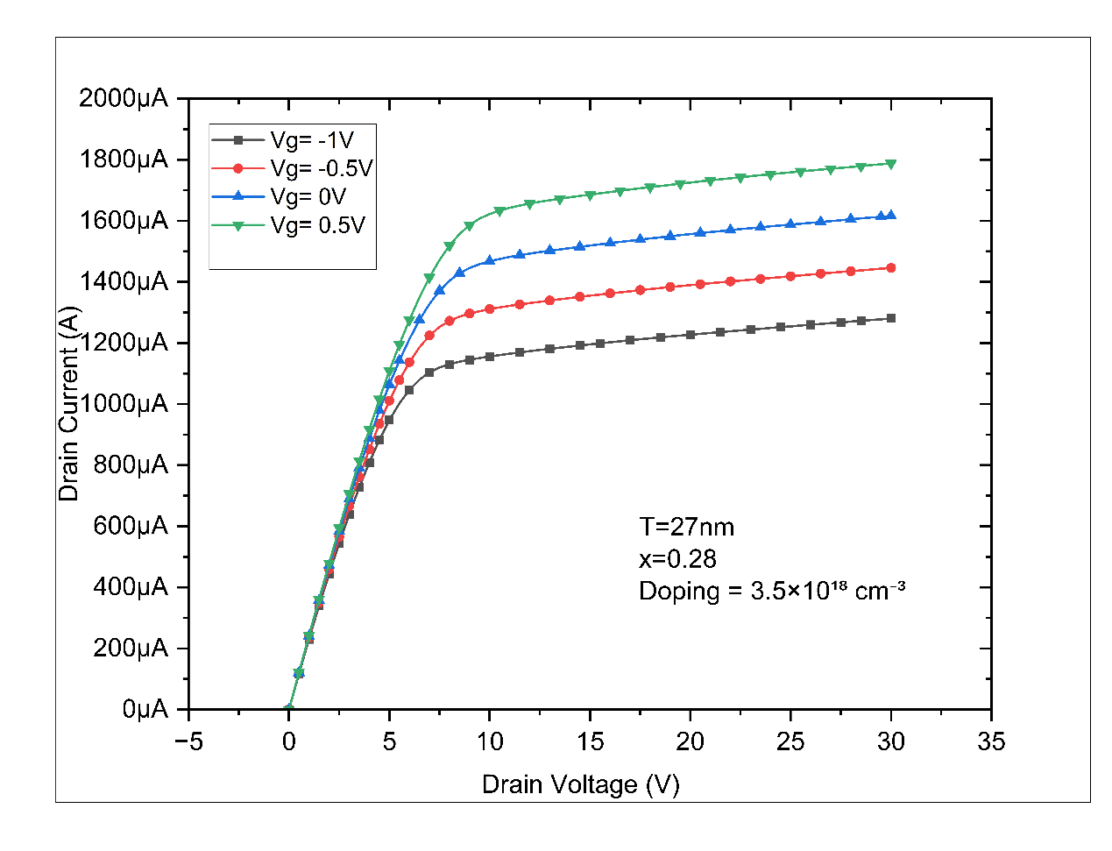

**Figure 4.15** Drain characteristics of AlGaN/GaN HEMT with AlGaN barrier thickness of 27 nm, Al mole fraction x=0.28, and doping concentration 3.5×1018 cm−3.

With the AlGaN barrier thickness fixed at 27 nm and aluminium mole fraction held constant at 0.28, the doping concentration was varied from 1.5×10¹⁸ cm⁻³ to 3.5×10¹⁸ cm⁻³ to evaluate its effect on the drain characteristics (**ID - VDS** ) of the HEMT. The plotted results show a clear trend of increasing drain current with higher doping concentrations. This occurs due to the enhanced formation of the two-dimensional electron gas (2DEG) at the AlGaN/GaN interface, resulting from increased ionized donor concentration. A higher 2DEG density improves channel conductivity and lowers sheet resistance, leading to improved current conduction under the same bias conditions. The **ID - VDS** curves become steeper with increasing doping, indicating enhanced output performance. However, very high doping levels may increase impurity scattering, leakage currents, and affect thermal stability. Therefore, optimizing the doping level is essential to maximize performance while ensuring device reliability and minimizing degradation effects.

**4.4.3.2 Effect of doping concentration on Transfer Characteristic (IDS – VGS)**

In AlGaN/GaN HEMTs, the level of doping in the GaN channel or barrier layer has a significant impact on the transfer characteristics (IDS–VGS). An increase in doping concentration leads to a higher carrier density, which in turn results in an increased drain current (IDS) at zero gate bias. However, this also causes a negative shift in the threshold voltage (VTH), necessitating a more substantial negative gate voltage to switch off the device. This alteration influences gate

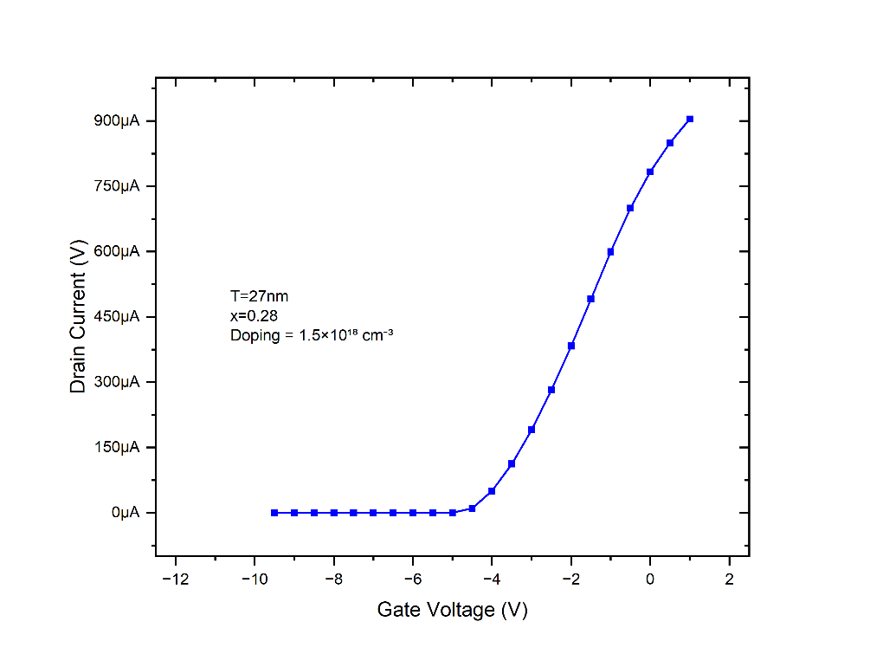

**Figure 4.16** Variation of Drain Current with Gate Voltage for Thickness 27 nm and Al Mole Fraction of 0.28, with Doping Concentration of 1.5×10¹⁸ cm⁻³.

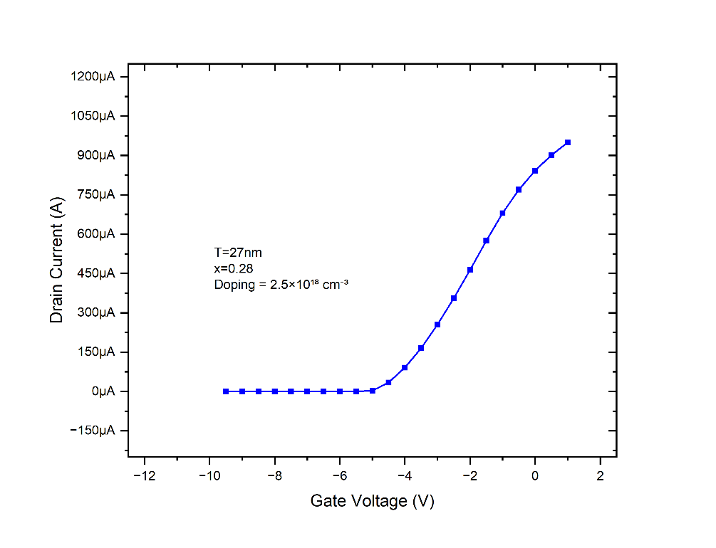

**Figure 4.17** Variation of Drain Current with Gate Voltage for Thickness 27 nm and Al Mole Fraction of 0.28, with Doping Concentration of 2.5×10¹⁸ cm⁻³.

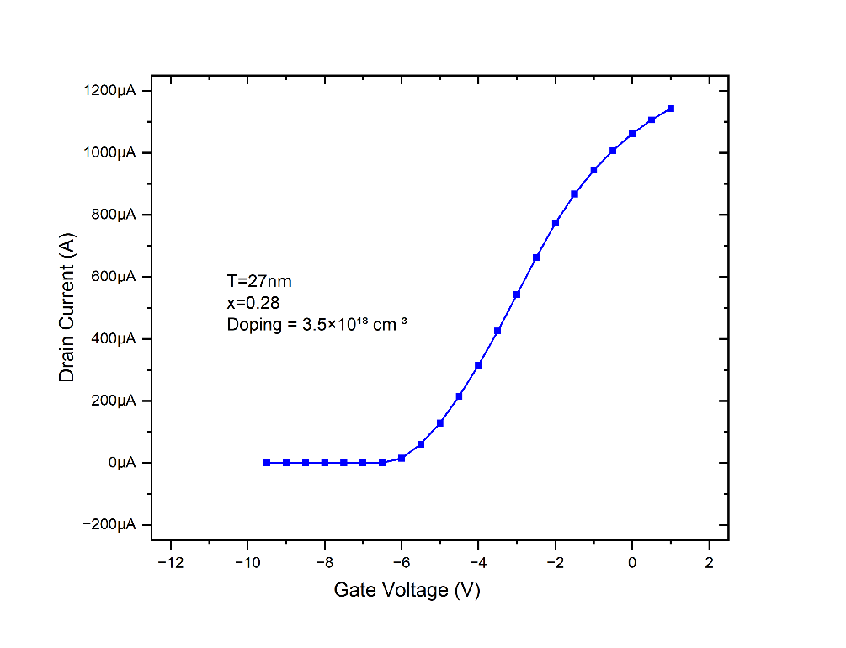

**Figure 4.18** Variation of Drain Current with Gate Voltage for Thickness 27 nm and Al Mole Fraction of 0.28, with Doping Concentration of 3.5×10¹⁸ cm⁻³.

In the simulated AlGaN/GaN HEMT results, elevating the doping concentration from 1.5 × 10¹⁸ cm⁻³ to 3.5 × 10¹⁸ cm⁻³ has a considerable effect on the transfer characteristics (IDS–VGS). With an increase in doping levels, the carrier concentration within the channel grows, resulting in a higher drain current at zero gate voltage. Nevertheless, this also leads to a more negative shift in the threshold voltage (VTH), necessitating a larger negative gate voltage to achieve current pinch-off. This shift has a direct impact on gate control, switching efficiency, and the overall performance of the device.

# CHAPTER 5

**CONCLUSION AND FUTURE WORK**

This chapter offers final insights derived from the comprehensive examination of the device features previously discussed. It also suggests possible pathways for subsequent research and development. The conclusion encapsulates the major findings, while the future work section emphasizes aspects that need further exploration to improve the performance and scalability of AlGaN/GaN HEMT devices.

**5.1 CONCLUSION**

This thesis thoroughly examined the performance of HEMT, particularly focusing on AlGaN/GaN HEMTs, utilizing SILVACO TCAD simulations. The research concentrated on the effects of essential structural parameters such as AlGaN barrier thickness, aluminium mole fraction, and doping concentration on both output (IDS–VDS) and transfer (IDS–VGS) characteristics across different bias conditions.

We found that increasing the AlGaN barrier thickness improves polarization at the AlGaN/GaN interface, which enhances the density of the two-dimensional electron gas (2DEG). This results in higher channel conductivity, an increase in drain current, and steeper transfer slopes. Notably, as the drain current rises, the threshold voltage (VTH) shifts in a more negative direction, indicating that a higher gate voltage is needed to fully deplete the channel and witch the device off.

In a similar manner, elevating the aluminium mole fraction intensifies the polarization field, leading to an increase in 2DEG density and further improving current conduction. While this enhances both output and transfer characteristics, it also leads to a more negative VTH, which necessitates careful management to ensure stable off-state performance.

Increasing the doping concentration directly boosts carrier density, resulting in increased drain current and sharper transfer curves. Nevertheless, it also induces a negative shift in the threshold voltage, which lowers the required turn-on voltage but may heighten the risk of off-state leakage.

In conclusion, achieving the best performance in depletion-type AlGaN/GaN HEMTs involves a careful balance of structural parameters, as these collectively influence 2DEG formation, drain current behaviour, and threshold voltage all vital for the effective operation of high-speed, high-power, and thermally stable devices.

**5.2 FUTURE WORK**

This study has generated important insights regarding how AlGaN barrier thickness, mole fraction, and doping concentration affect the output characteristics of AlGaN/GaN HEMTs, yet several techniques remain for additional investigation and improvement.

To begin with, future research could broaden the current analysis by widening the gate and other terminals. Given that GaN-based HEMTs are frequently utilized in high-power and high-temperature settings, investigating the thermal stability and performance of the 2DEG at elevated temperatures would provide valuable information concerning device durability and long-term dependability.

Moreover, integrating trap and surface states into the simulations would enhance the accuracy of the model. Surface traps, especially at the AlGaN/GaN interface or within passivation layers, have a significant effect on current collapse and dynamic on-resistance. Including these factors would lead to a more precise depiction of actual device performance and assist in devising techniques for mitigation.

In addition, the effects of either graded or step AlGaN barrier configurations could be investigated. Rather than utilizing a uniform Al composition, a graded barrier could improve carrier confinement and decrease lattice mismatch, potentially resulting in better 2DEG mobility and reduced interface trap densities.

Examining new gate designs, such as recessed gates, T-gates, or hybrid configurations, could also be beneficial. These designs might be assessed for their influence on threshold voltage regulation, current saturation, and high-frequency capabilities, particularly when coupled with the optimized structural parameters determined in this research.

Furthermore, exploring various substrate materials, such as SiC or diamond, could be worthwhile. These substrates have superior thermal conductivity compared to silicon and could greatly enhance heat dissipation, facilitating higher power operation and further refinement of electrical performance.

Lastly, moving from simulation to experimental validation is a logical subsequent step. Producing and characterizing devices with the identified optimal parameter sets would validate the simulated trends and allow for adjustments to the models employed.

In closing, the foundational knowledge acquired through this thesis provides a robust basis for enhancing the performance and reliability of AlGaN/GaN HEMTs, offering numerous avenues for further development and practical implementation.

**REFERENCES**

|  |  |
| --- | --- |
| [1] | S. Mukhopadhyay and S. Kalita, “Report on the effects of mole fraction, doping concentration, gate length and nano-layer thickness to control the device engineering in the Nanoelectronic AlGaN/GaN HEMTs at 300 K to enhance the reputation of the National Institute of Technology Arunachal Pradesh”, Nano Trends, Vol. 19 (2017) Pages 15-47. |
| [2] | S. Mukhopadhyay, “Report on the Novel Electrical Characteristics of Microelectronic High Electron Mobility Transistors to Establish a Low-Cost Microelectronics Laboratory in the National Institute of Technology Arunachal Pradesh”, Journal of Semiconductor Devices and Circuits, 4 (2017) Pages 6-28. |
| [3] | M. K. Chattopadhyay and S. Tokekar, “Thermal model for dc characteristics of AlGaN/GaN HEMTs including self-heating effect and non-linear polarization”, Microelectronics Journal, 39 (2008) Pages 1181-1188. |
| [4] | Sanjib Kalita and Subhadeep Mukhopadhyay. “Variations of Source Current in the Double-Heterojunction HEMTs”. Journal of Semiconductor Devices and Circuits. 2016; 3(3):Pages 19–24 . |
| [5] | Juncai M, Jincheng Z, Junshuai X, et al. Journal of Semiconductors (JoS). 2012; 33: 014002p. |
| [6] | Wesley Scott Newham “Development of AlGaN/GaN High Electron  Mobility Transistors (HEMTS) On Diamond Substrates” June 2006 pages 7-20. |
| [7] | S. M. Sze and Kwok K. Ng “Physics of Semiconductor Devices” |
| [8] | M. K. Chattopadhyay and S. Tokekar, “Analytical model for the transconductance of microwave AlmGa1-mN/GaN HEMTs including nonlinear macroscopic polarization and parasitic MESFET conduction”, Microwave and Optical Technology Letters, 49 (2007) Pages 382-389. |
| [9] | M. Korwal, S. Haldar, M. Gupta and R. S. Gupta, “Parasitic resistance and polarization-dependent polynomial-based non-linear analytical charge-control model for AlGaN/GaN MODFET for microwave frequency applications”, Microwave and Optical Technology Letters, 38 (2003) Pages 371-378. |
| [10] | S. Khandelwal, N. Goyal and T. A. Fjeldly, “A Physics-Based Analytical Model for 2DEG Charge Density in AlGaN/GaN HEMT Devices”, IEEE Transactions on Electron Devices, 58 (2011) Pages 3622-3625. |
| [11] | S. Khandelwal, N. Goyal and T. A. Fjeldly, “A precise physics-based compact model for 2-DEG charge density in GaAs HEMTs applicable in all regions of device operation”, Solid-State Electronics, 79 (2013) Pages 22-25. |
| [12] | ] C. C. Cheng, Y. Y. Tsai, K. W. Lin, H. I. Chen, W. H. Hsu, C. W. Hung, R. C. Liu and W. C. Liu, “Pd-Oxide-Al0.24Ga0.76As (MOS) High Electron Mobility Transistor (HEMT)-Based Hydrogen Sensor”, IEEE Sensors Journal, 6 (2006) Pages 287-292. |
| [13] | X. Yu, C. Li, Z.N. Low, J. Lin, T.J. Anderson, H.T. Wang, F. Ren, Y.L. Wang, C.Y. Chang, S.J. Pearton, C.H. Hsu, A. Osinsky, A. Dabiran, P. Chow, C. Balaban and J. Painter, “Wireless hydrogen sensor network using AlGaN/GaN high electron mobility transistor differential diode sensors”, Sensors and Actuators B, 135 (2008) Pages 188-194. |
| [14] | F. M. Yigletu, S. Khandelwal, T. A. Fjeldly and B. Iniguez, “Compact Charge-Based Physical Models for Current and Capacitances in AlGaN/GaN HEMTs”, IEEE Transactions on Electron Devices, 60 (2013) Pages 3746-3752. |
| [15] | S. Ghosh, A. Dasgupta, S. Khandelwal, S. Agnihotri and Y. S. Chauhan, “Surface-Potential-Based Compact Modeling of Gate Current in AlGaN/GaN HEMTs”, IEEE Transactions on Electron Devices, 62 (2015) Pages 443-448 |
| [16] | S. Bhuyan and A. Dey, “TCAD simulation of AlGaN/GaN HEMT grown on high-resistivity silicon” *AIP Conference Proceedings*, Vol. 2898, 2024, Pages 030064. |
| [17] | S. Zhou, L. Wang, X. Yang and H. Zhang, “Ultra-Thin Double Barrier AlGaN/GaN High Threshold Voltage HEMT with Graded AlGaN/Si₃N₄ Gate and p-Type Buffer Layer” *Journal of Computational Electronics*, 22 (2023), Pages 145–154. |
| [18] | Y. Zhang, Y. Liu, C. Huang and Z. Li, “Optimization of AlGaN/GaN HEMT with Field Plate Structures” *Micromachines*, Vol. 13(5), 2022, Pages 702. |
| [19] | D. Wang, J. He, X. Lin and B. Chen, “Performance Enhancement of Normally-OFF AlGaN/GaN HEMT Using Delta Doping” *Semiconductors*, Vol. 57(1), 2023, Pages 145–152. |
| [20] | L. Peng, Q. Zhang and T. Liu, “Simulation of Single-Event Transient Effect for GaN High-Electron-Mobility Transistor” *Micromachines*, Vol. 14(10), 2023, Article 1948. |